Final Race Instructions
Its Grim up North Running – Hey up its Helmsley

GOVERNING BODY: The Trail Running Association

Sunday 16th July

RACE HEADQUARTERS:

Duncombe Park, Helmsley, York, YO62 5EB

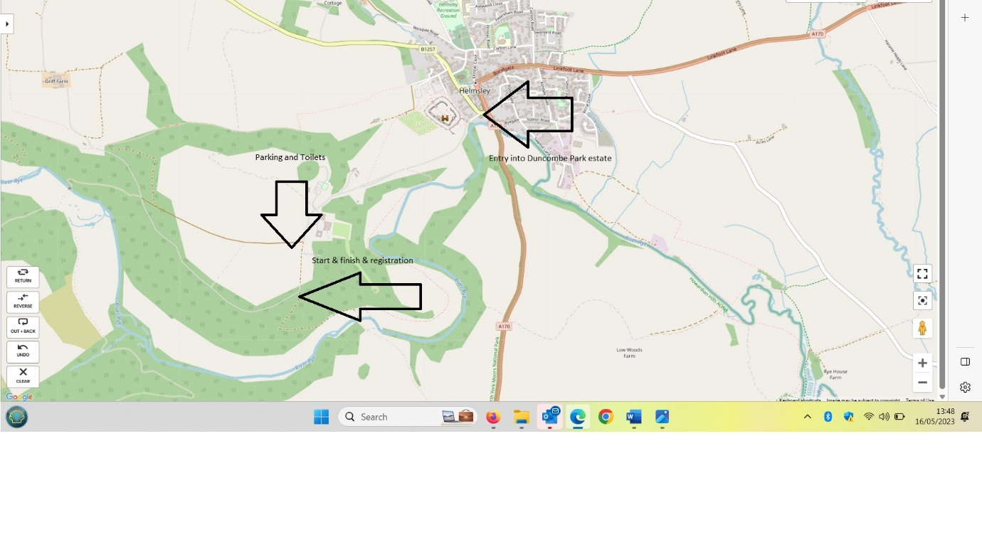
GETTING TO US AND PARKING (See map above)

PLEASE NOTE THERE WILL BE A £5 CHARGE PER CAR FOR PARKING IN THE GROUNDS OF DUNCOMBE PARK, IT WOULD BE HELPFUL IF YOU HAD THE CORRECT MONIES.

FACILITIES

Toilets are available within the parking area.

GRIM MASSAGE

Adam will be available for both pre-race and post-race massage. He his brilliant. You can pay by either cash or card.

REGISTRATION
Is just off the edge of the car park (see map)

Distance | Registration opens | Start
Early bird marathon & ultra only by request | 08:00 | 08:30
Ultra | 08:45 | 09:30
Marathon | 08:45 | 09:30
20 Miler | 09:00 | 10:00
Half Marathon | 09:00 | 10:00
6.7 Miler | 10:00 | 11:00

BAGGAGE DROP

There will be a baggage drop, in the Grim van which will be available at the start and finish area.

THE ROUTE

The route is measured by Plot-a-route and Garmin. The route is a 6.7-mile loop.

https://www.plotaroute.com/route/2252966

Marshals will be placed along the route and on the water/feed stations. The route is undulating and a mixture of tarmac, field, trail, steps and traily trail, it is a gorgeous route. There may be a small amount of traffic on the road in and out of Duncombe Park, please take care.

There will be marshals at all turnaround points and other strategic places. Water/Feed approx. every 3 M

Ultra x 5 loops (approx. 33 miles)
Marathon x 4 loops
20 Miler x 3 loops
Half x 2 loops
10k, is a 10k loop.

RACE SHOES

The route is mainly trail, good trail if dry.

DURING THE RACE

Please do not litter, take all gel wrappers etc with you or leave with a marshal.

We hope to start all the races promptly. Please inform a race official if you are unable to complete the course and need to withdraw for any reason, please hand your race number to the official. Please assist officials by making sure your number is visible. Always wear your race number on the front of your vest.

Please be aware of all other users of the estate and be kind and courteous.

THE RACE

The race starts and finishes in the same place.

WATER AND FEED STATIONS

This is cupless event. All runners are requested to bring their own labelled, reusable cup or bottle. We are happy to fill your bottles before, during and after the event. We’ll have feed stations every 2.5 miles. We’ll provide water, squash, cola as well as crisps and savoury snacks. Please use the bins provided. If you don’t have your own bottle/cup, we sell reusable, squashable cups for £5.

HEADPHONES
We do not want to spoil the enjoyment of the event for the competitors, but we do not endorse the use of MP3 players, or similar devices, for the following safety reasons:
Runners cannot always hear the marshals’ instructions.
Runners may not hear cyclists behind them and stray into their path.
Bone conduction earphones are allowed.

YOUR REWARD AT THE END

Relief
Bespoke medal
All our events have lots of lovely things at the finish line. As we love to celebrate every runners’ achievements. All our runners are winners.

WEATHER

Please keep an eye on the forecast and dress appropriately.

GRIM Looks forward to welcoming you next week.

